1. 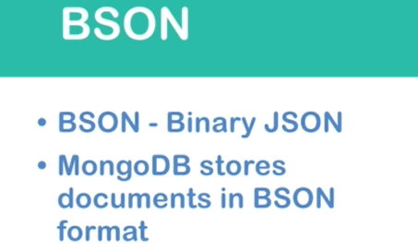
2. Why do we need this format even though we have JSON?
3. JSON supports just 6 data types where BSON supports much more.
4. 